#129
Product Description: |  |  |  |  |  |  |  |  |  |  |  |  |  |  |  |  |  |  | Product Film Type:
Product Generic ID#: |  | T50SM-MAG |  |  |  |  |  |  |  |  |  |  |  |  |  |  |  |  | 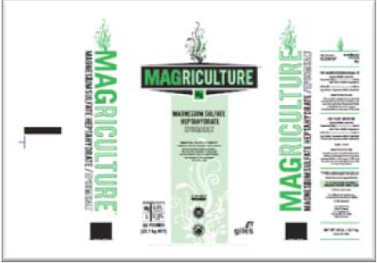
Product Grade: |  | Tech
Product Screen: |  | Screened 60
Packaging Weight: |  | 50lb
Pallet Configuration: |  | 7x7
Other: |  | Magriculture
Quality:
 | - Samples to be taken |  |  |  |  |  |  | Retained for:
 | - Testing Required |  |  |  |  |  |  | Testing for:
 | - Quality Release |  |  |  |  |  |  | Criteria Needed:
Production/Packaging:
 | - Shrink Wrap |  |  |  | - Liners Required |  |  |  |  |  |  |  |  |  |  | - Heat Treated Pallets |  |  |  |  |  |  |  |  |  |  | - Stickers Required
 | - Extra Placard or Tag Required: |  |  |  |  |  |  |  |  | Description:
 | - Other Requirements: |  |  |  |  |  | Description:

Shipping:
 | - General |  |  | - Air Bags |  |  |  |  |  |  |  |  | - Double Wrap |  |  |  |  |  |  |  |  |  |  | - Corner Boards |  |  |  | - Block & Brace
 | - Must have Quality Approval signature before loading: |  |  |  |  |  |  |  |  |  |  |  |  |  |  |  |  |  |  | Reason:
 |  |  |  |  |  |  |  |  | Signature: |  |  |  |  |  |  |  |  |  |  |  |  |  |  |  |  |  |  | Date:
 | - Must have Management Approval signature before loading: |  |  |  |  |  |  |  |  |  |  |  |  |  |  |  |  |  |  |  | Reason:
 |  |  |  |  |  |  |  |  | Signature: |  |  |  |  |  |  |  |  |  |  |  |  |  |  |  |  |  |  | Date:
 | - Other:
Change Information: |  |  | General update of entire form.
New SCR code for Magriculture on Heat Treated pallets stacked 7x7.

